Name: R. Samshritha
Roll No: 2520030045
Subject: Operating Systems and Systems Programming (OSSP)
Skill No: 2
Title : To Create Main Loop, Display Prompt, Read User Input, Handle Exit Conditions, Design Control Flow Diagram, Test Interactive Loop To Capture Keyboard Input, Handle Backspace, Process Enter Key, Manage Input Buffer, Support Multi-Character Commands, Test User Interaction this is a skill work in my operating system class i need to do the assignment how to do

CODE:

SKILL2.C CODE:
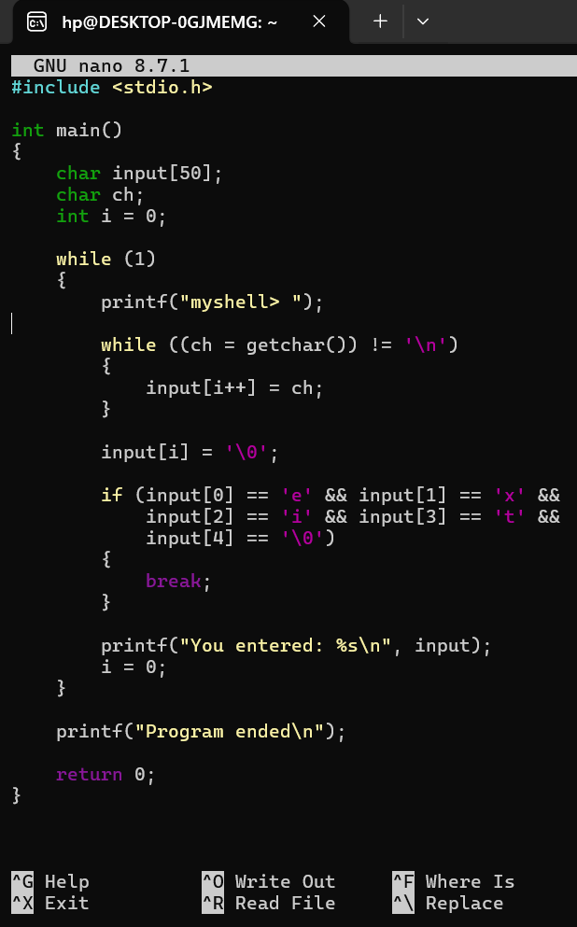
SKILL2PART2.C CODE:
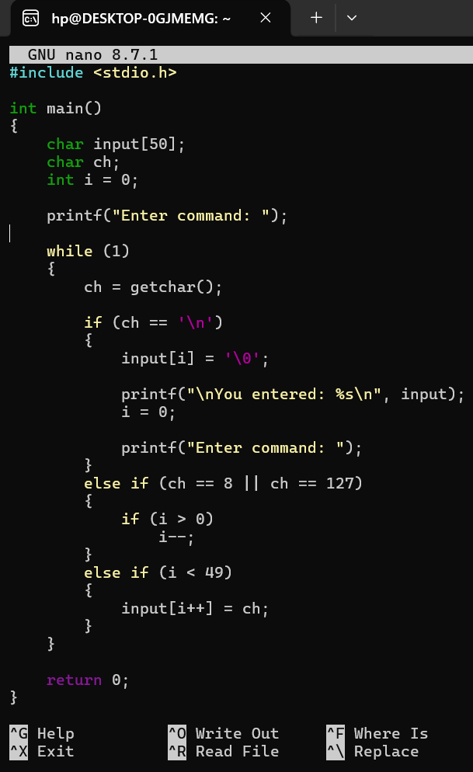

EXECUTION :

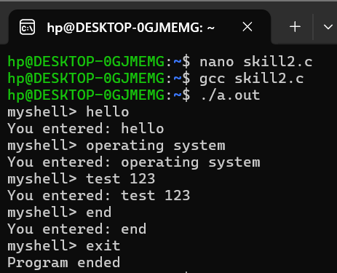
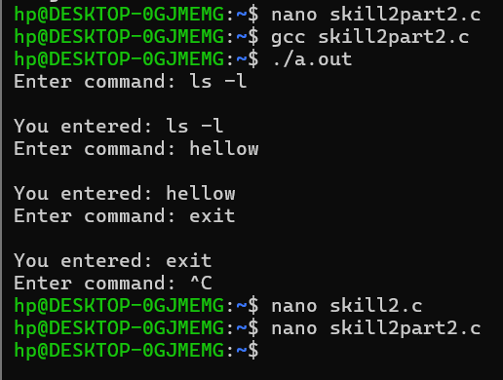

OUTPUT:

